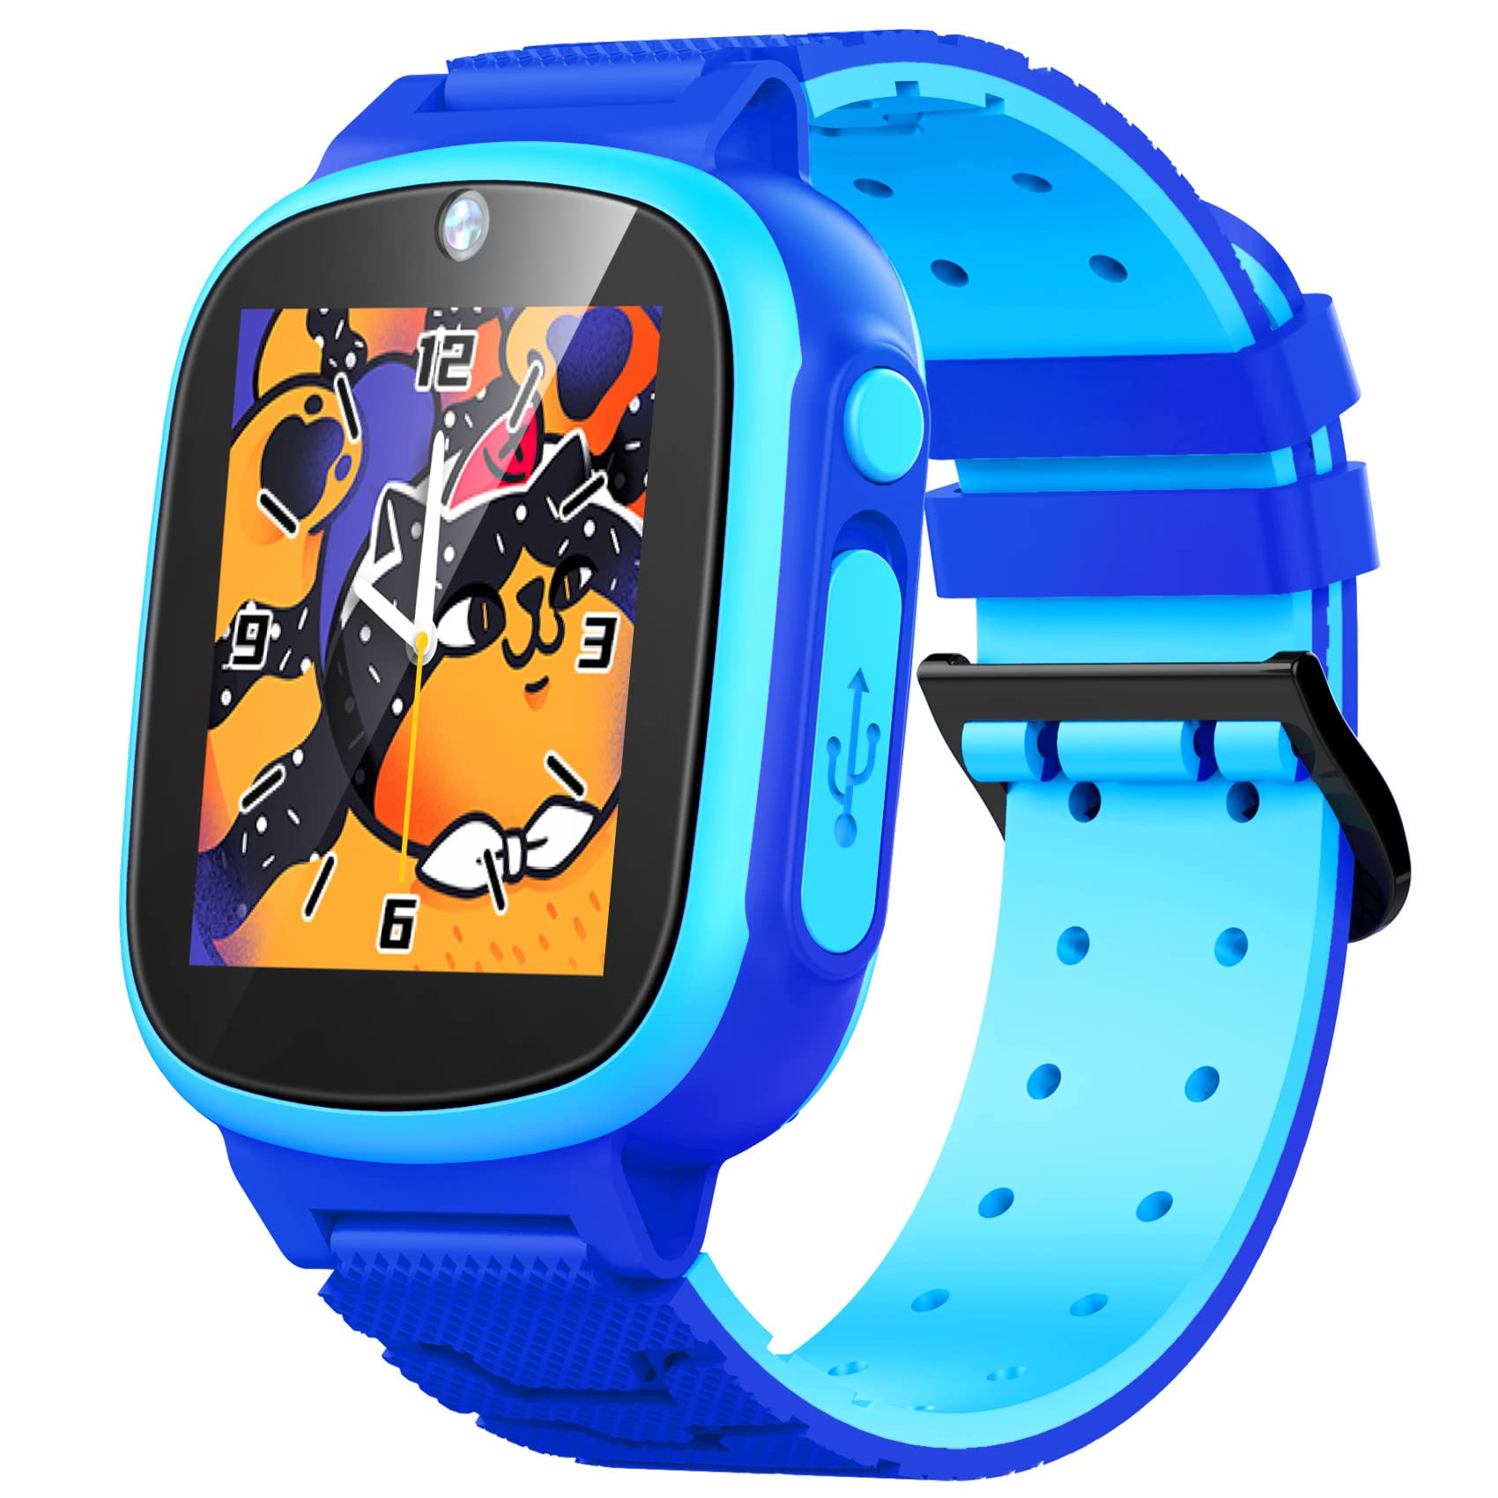**Description**: Facasu specializes in children's digital watches that are both functional and fun. Designed for kids aged 4 to 10, these watches feature colorful light displays, making it easy for children to read the time, even in the dark. The large digital display ensures clarity, and the watch lights up with different colors, adding to its appeal. Each watch undergoes vacuum pressure testing and incorporates three waterproofing processes, making it suitable for daily activities like washing hands, playing in the rain, or swimming. However, it's important to note that the watch should not be used in high-temperature environments, and the knob should not be pulled out while in water. The soft silicone strap is adorned with various patterns, such as animals, dinosaurs, and rockets, catering to different interests. Additional features include time, week, calendar, alarm, stopwatch, 12/24-hour format